QECSN
Network Meeting - Term 4
Exploring the UNESCO Sustainable Development Goals

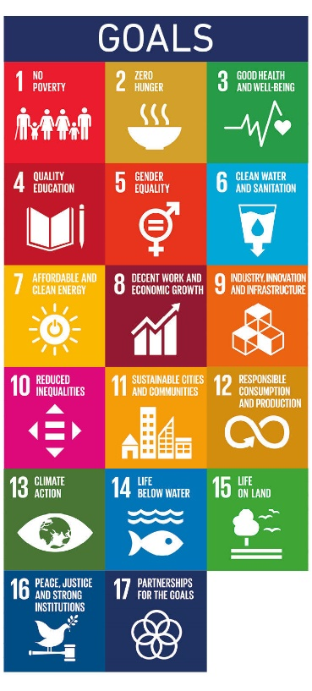
This Term our Network Meeting will focus on a discussion about how our early childhood education for sustainability (ECEfS) practices integrate with the 17 Sustainable Development Goals and the NQS.
The pressing need for sustainable development to meet the needs of current and future generations underpins the Sustainable Development Goals (SDGs) (UNESCO, 2017). These goals reflect the global complexity of sustainability across four dimensions (natural, economic, social and political).
Come and join in our practice-based discussions at Kindred Early Education in Brisbane.
When- Saturday 14th of November from 9 AM until 12 PM.
Where- 163-165 Richmond Road, Morningside, QLD
What to Bring- water bottle and an inquisitive mind

There will be a Covid plan in place and numbers will be limited to 30 for the event.
Please get your ticket via the Humanitix site below.
Tickets are free for QECSN members and $30 for non-members.
https://events.humanitix.com/exploring-the-unesco-sustainable-development-goals

